**IT Discover Hub Website**

**Introduction**

Ever wished for a digital oasis or stand for Organization for the Advancement of Structured Information Standards, where information seamlessly converges, community thrives, and your interests find a home? Enter the realm of the hub website, where curiosity meets connectivity, and a world of knowledge and collaboration awaits at your fingertips. A hub website is a centralized online platform that acts as a focal point for information, services, or activities related to a specific topic, industry, or community. These platforms serve as comprehensive sources, aggregating and organizing information from various sources to provide users with a one-stop destination for their specific needs or interests. Hub websites can range from informational hubs that curate content to collaborative hubs facilitating communication and collaboration among users with common interests. They play a crucial role in simplifying online navigation, fostering community engagement, and delivering a cohesive online experience for users seeking concentrated information in a specific domain. So, that we proposed system named IT Discover Hub Website which is an IT product catalog and comparison website that allows users to compare and contrast different IT products, such as software, hardware, and cloud services. This type of website is valuable for businesses and individuals who are looking to purchase new IT products and want to make informed decisions. And it provides users with comprehensive access to the latest resources, news, and developments in the IT industry. The hub streamlines navigation, saving time and effort in searching for scattered information across various sources. And it fosters community engagement, offering a space for networking, discussions, and collaboration among IT professionals and enthusiasts. The collaborative features enhance opportunities for knowledge sharing and project collaboration.

The proposed IT Hub Discover Website caters to a diverse audience, including businesses and individual consumers in the realm of information technology. For businesses, the platform targets IT professionals, decision-makers, and procurement teams involved in the acquisition of software, hardware, and cloud services for organizational use. It also serves business owners looking to upgrade or expand their IT infrastructure. Individual consumers, ranging from those seeking personal IT products to tech enthusiasts staying abreast of the latest technologies, form another significant audience. The site appeals to IT enthusiasts, including students, professionals, and hobbyists, who want to stay updated on the latest IT products. Additionally, tech reviewers and influencers find value in the platform as a reliable source for detailed product information and comparisons. Lastly, the website caters to IT consultants who need to stay informed about the latest products and technologies to provide valuable advice to their clients. The inclusive features, such as product recommendations, reviews, and advanced filtering, make the IT Discover Hub Website a comprehensive resource for a wide spectrum of users in the IT landscape.

Furthermore, The IT Discover Hub Website serves as a valuable resource for businesses and individuals seeking to make informed decisions when purchasing IT products. The platform offers a range of functions to enhance the user experience, including a robust product search feature that allows users to search for products using keywords, categories, filters, and advanced search options. The product catalog provides a comprehensive list of IT products, displaying detailed information such as specifications, features, pricing, and vendor details. Users can utilize the product comparison tools to evaluate multiple products side-by-side, highlighting key differences and similarities. The inclusion of user reviews and ratings offers valuable insights to potential buyers, while advanced filtering options help narrow down search results based on specific criteria. The website also features product recommendations based on user history, along with wish lists and favorites for convenient future reference. With a focus on user engagement, the platform incorporates a feedback system for users to report issues, suggest improvements, or seek assistance, contributing to a dynamic and user-friendly IT product discovery experience.

**Project Overview**

The main objective of the website known as ITDiscover Hub is to provide a platform that is both powerful and user-friendly, and that also functions as a comprehensive resource for individuals and enterprises who are navigating the complex world of information technology product choices. By providing customers with efficient search functions, advanced filters, and categorization, the project intends to simplify the process of discovering new products and comparing them to one another. This will enable users to locate the most appropriate information technology solutions. The platform's goal is to provide users with an enhanced experience by providing a comprehensive catalog of information technology products. This catalog includes information on the products' specifications, features, pricing, and vendor data, which makes it easier for users to make decisions that are well-informed. Additionally, the ITDiscover Hub aims to encourage community involvement by enabling users to contribute through reviews and ratings, thereby delivering useful insights and establishing trust among members of the user community. There is a further enhancement of user interaction and retention through the usage of personalized suggestions that are based on user behavior, wish lists, and favorites. The project also places an emphasis on effective product database administration in order to guarantee that the information supplied is accurate and up to date, hence enhancing the dependability of the platform. For the purpose of addressing user issues in a timely manner and contributing to an overall positive user experience, a comprehensive feedback and support system has been established. The ultimate goal of the ITDiscover Hub is to become a platform that is both dynamic and scalable, so that it may continue to evolve with the information technology sector and continue to be a dependable and important resource for users who are looking for knowledge and support in the field of IT product selection.

The ultimate resource for anyone who needs to navigate the diverse world of IT products is IT Discover Hub. We strive to simplify product discovery with powerful search, filters, and clear categorization, enabling you to compare solutions side-by-side and make informed choices. Detailed product information, user reviews, and personalized recommendations empower you to find the perfect fit. Beyond products, we foster a thriving community through user-driven content, discussions, and networking opportunities, allowing knowledge sharing and collaboration to flourish. Our priority is to maintain accurate and up-to-date information, backed by responsive support, while continuously evolving to stay ahead of the IT curve. Ultimately, IT Discover Hub aspires to be your trusted partner in making informed IT product decisions, connecting you with the right solutions and a vibrant community.

IT Discover Hub boasts a powerful and user-friendly platform that serves as a comprehensive resource for individuals and enterprises navigating the intricate landscape of information technology products. With efficient search functions, advanced filters, and categorization, the platform simplifies the discovery and comparison of new products. A detailed product catalog includes specifications, features, pricing, and vendor data, enabling users to make well-informed decisions. Community involvement is encouraged through user-contributed reviews and ratings, fostering trust among members. The user experience is further enhanced with personalized suggestions based on behavior, wish lists, and favorites. The platform is designed to be dynamic and scalable, evolving with the information technology sector to remain a valuable resource. Effective product database administration ensures the accuracy and timeliness of information, reinforcing the platform's dependability. A comprehensive feedback and support system addresses user issues promptly, contributing to an overall positive experience. Ultimately, IT Discover Hub aims to be a trusted and indispensable resource, supporting users in the complex realm of IT product selection.

A powerful and seamless user experience is delivered by the IT Discover Hub through the use of a suite of cutting-edge technologies. For coding, the system relies on Vscode, a versatile and widely-used source code editor known for its flexibility and robust features. Database management is facilitated by XAMPP, a comprehensive solution that includes Apache, MySQL, PHP, and Perl, ensuring efficient and secure data handling. Interfaces are built using Figma, a collaborative interface design tool that streamlines the creation of visually appealing and user-friendly interfaces. In terms of programming languages, the system incorporates a blend of front-end languages (HTML, CSS, JavaScript) and back-end languages (PHP with MySQL), enabling dynamic and interactive web development. This combination of technologies not only ensures a robust and scalable platform but also facilitates the creation of a comprehensive IT product catalog and comparison website that meets the diverse needs of businesses, IT professionals, enthusiasts, and consultants alike.

**System Architecture**

IT Discover Hub's primary function is to enable individuals and businesses to successfully traverse the intricate terrain of available information technology products. The platform is built on a layered architecture for adaptability and scalability, and it makes use of a robust search engine, advanced filters, and insightful product categorizations in order to simplify the process of discovery and comparison. Users are able to obtain access to extensive information, side-by-side comparisons, and suggestions, all within an interface that is easy to use, regardless of whether they are exploring cloud solutions, software, or hardware. IT Discover Hub places a high priority on scalability, performance, and security in order to provide a seamless and safe experience for its expanding user base. This is driven by the goals of supporting educated decision-making and being a trusted resource for information technology.

Users can explore and contrast IT goods that are offered globally on the IT Discover Hub website. This platform is made up of features or modules that focus on finding, navigating, and contrasting goods that the user could find helpful. The user component and the admin component are the two main parts of the IT Discover Hub component. The product search module, which enables the user to look for particular IT goods or services, is one of the many modules in the user component that are visible and functional within the system. product catalog, which lists and illustrates IT items. Product comparison allows the user to evaluate a product's specifications, price, and features. Users can evaluate products and post reviews on this site thanks to user ratings and reviews. The search experience is improved with advance filtering. Suggestions for products, news, user support and comments, favorites and wishlists, and much more. Modules like product database management, which oversees the IT product database, are displayed on the admin component. Management of user reviews and ratings, which controls and modifies reviews and ratings. The administration of user accounts and support is done by user support management. News administration as well as setup and upkeep of the system.

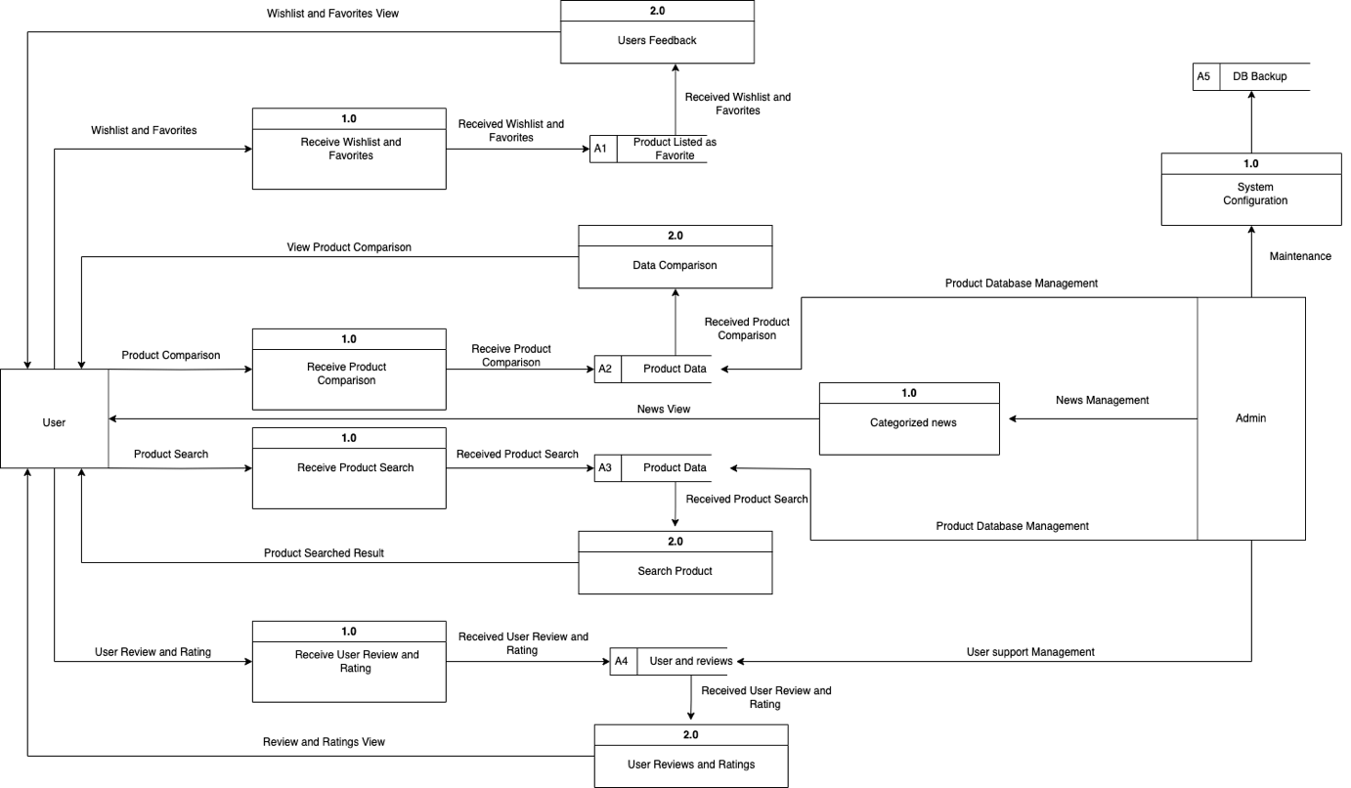

Figure 3.0

Data Flow Diagram of the System Develop

**Site Structure**

The IT Discover Hub website boasts a user-friendly site structure, guiding visitors through an organized exploration of diverse technology categories. Starting from the Home page, users can delve into detailed information about Smartphones, Laptops and Desktops, Graphics Cards, Peripherals, and Printers, with the option to view specific brands within selected categories. The "See All" feature provides a quick overview, directing users to the comprehensive Catalog Page. The "About Us" section offers insights into the organization, including details about the team and ways to get in touch. The Catalog page serves as a central hub for detailed technology specifications, complemented by the News section for the latest tech updates. The "Contact Us" page facilitates communication, providing social media links and contact numbers. This site structure ensures a seamless and informative user experience, allowing visitors to explore technology offerings, stay updated on industry news, and connect with the IT Discover Hub team.



Figure 5.2

Navigation Menu of IT Discover Hub

Figure 5.1

Sitemap of IT Discover Hub

**Design and Layout**

**Introduction:**

People interested in learning more about the field of information technology will find the IT Discover Hub's user interface (UI) to be straightforward and easy to use. The design easily includes essential features and capabilities, prioritizing efficiency and simplicity to improve the user experience.

**Key Features:**

**I. Navigation Bar:**

A clean and accessible navigation bar at the top provides easy access to core sections such as Home, About Us, Catalog, News, and Contact Us.

**II. Homepage:**

The homepage welcomes users with a visually appealing layout featuring curated content, trending topics, and quick links to popular categories.

**III. Category Exploration:**

Users can delve into specific IT categories, each represented by visually distinctive icons. Intuitive filters and sorting options streamline the exploration process.

**IV. Search Functionality:**

A robust search feature allows users to find relevant IT topics, articles, and resources quickly. Autocomplete suggestions enhance the search experience.

**V. Content:**

Visually appealing content is presented concisely, utilizing a grid layout for easy scanning. Each piece includes essential details, such as the title and a brief description. Explore a diverse range of IT technologies, including laptops for on-the-go productivity, mobile phones for seamless communication, powerful desktops for intensive tasks, sleek tablets for versatile computing, and innovative Apple Watches for wearable connectivity

**Visual Design:**

**I. Color Scheme:**

The color scheme for the IT Discover Hub features a modern and professional palette:

**Primary Background**: linear-gradient(to bottom, #070320, #050D7C, #2B36B5) - A linear gradient from a deep, rich navy blue to the same navy blue, adding a subtle gradient effect for a tech-savvy aesthetic.

**Accent Color**: #D80027 - A vibrant red accent adds energy and visual interest.

**Text and Content**: #FFFFFF - Crisp white ensures clear and legible typography, maintaining a clean and inviting look.

**Navigation and Interactive Elements**: #FFFFFF and #DC7000 - A classic white and orange is used for navigation elements, providing a visually distinct and sophisticated appearance.

**II. Typography:**

**Font**: Poppins - A modern and clean sans-serif font.

**Heading Font Size**: 24px - Used for section titles and headings, providing a bold and prominent appearance.

**Body Font Size**: 16px - Applied to paragraph text and other content, ensuring readability and a comfortable reading experience.

**Content**

**Text Content**

The IT Discovery Hub's home page invites visitors to explore further by highlighting current IT trends and introducing the organization's objective. Regular entries on the newest IT trends, in-depth evaluations of the latest technologies, and guest parts from professionals in the field may all be found on the Technology Blog. Guide guides and tutorials for the users and experts provide step-by-step instructions, making learning simple. Users may remain up to date on market trends, projections, and the most recent news by visiting the newsarea. This all-inclusive platform offers dynamic material for investigating different aspects of the IT environment.

**Images and Media:**

The Photo Galleries section of the IT Discovery Hub captivates users, showcasing the latest gadgets and equipment in the IT industry. It goes beyond the surface, providing latest IT equipment and gadgets highlighting not just the aesthetics but also the functionality of cutting-edge devices.

In the realm of Video Content, the hub offers engaging content that includes explainer videos on trending technologies, insightful interviews with IT experts, and the latest news updates presented in video format. This multimedia approach ensures a dynamic and informative experience for users seeking diverse perspectives on the ever-evolving IT environment.

**Content Management System (CMS):**

The Content Management System (CMS) at the heart of the IT Discovery Hub prioritizes user-friendly functionality. Its intuitive dashboard simplifies content creation and management, providing a seamless experience for users. The CMS relies on multimedia integration to provide a dynamic content experience. Users may easily share their experiences, and the system allows for the easy integration of other media, resulting in visually appealing and diversified material. In addition, the CMS has powerful organizing features such as Categorization and Tagging, with well-organized categories for various content kinds and a tagging system that improves information retrieval efficiency. Collaboration is eased using user accounts that provide various access levels and collaboration features that allow numerous writers and contributors to contribute seamlessly. In conclusion, the CMS acts as a solid basis, enabling effective content management and collaborative activities within the IT Discovery Hub.

**Functional Components**

IT Discover Hub is a comprehensive online platform designed for exploring and contrasting various technologies. This website serves as a centralized hub where users can gain insights into the latest advancements, trends, and comparisons across different IT domains. IT Discover Hub provides a user-friendly interface for navigating through detailed information and expert analyses. By offering a wealth of resources, reviews, and side-by-side comparisons, the platform empowers technology enthusiasts, developers, and decision-makers to make informed choices and stay abreast of the ever-evolving landscape of information technology.

The User’s Module encompasses various features designed to enhance the overall experience of interacting with IT products and services. The Product Search functionality enables users to locate specific items through keyword searches and advanced filters. The Product Catalog presents a comprehensive array of IT offerings, categorized for easy navigation, and includes detailed information on each product or service. Users can utilize the Product Comparison feature to assess multiple items side by side, with the ability to highlight differences in features, prices, and specifications. The platform further encourages user engagement through the User Reviews and Ratings section, where individuals can share their experiences, provide star ratings, and contribute written reviews. Advanced Filtering options enhance the search experience by allowing users to refine results based on brand, price range, and features. Personalization is taken a step further with Product Recommendations, driven by artificial intelligence and user history analysis. The module also facilitates organization with Wish Lists and Favorites, permitting users to save desired items for later and share their curated lists. Additionally, a User Feedback and Support channel is available, featuring a contact form and an FAQ section for user inquiries. The News section keeps users informed about the latest happenings in the IT industry, presenting categorized articles and a dedicated section for the most recent news updates.

The Admin’s Module serves as a central hub for efficient management of various aspects within the IT ecosystem. The Product Database Management component oversees the IT product and service database, offering functionalities such as the addition, editing, or removal of products. The module also streamlines processes with the ability to bulk upload products. User Reviews and Ratings Management is another critical function, focusing on the moderation and administration of user-generated content. This includes an approval system and a mechanism for flagging inappropriate content to maintain a high standard of quality. System Configuration and Maintenance are integral to the module, enabling administrators to manage system settings and conduct routine maintenance tasks. This involves system configuration adjustments and regular database backups to ensure data integrity and system reliability. Lastly, the News Management feature facilitates the control of news articles related to the IT industry, allowing administrators to add, edit, or remove articles and categorize them for organized presentation. Together, these features empower administrators to efficiently oversee and maintain the IT ecosystem, ensuring a smooth and well-managed operation.